**Marketing**

Mostafa Elsawy

Head of marketing committee

<https://www.linkedin.com/in/mostafa-elsawy-2926a01a4>

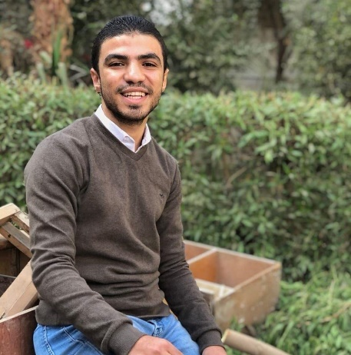

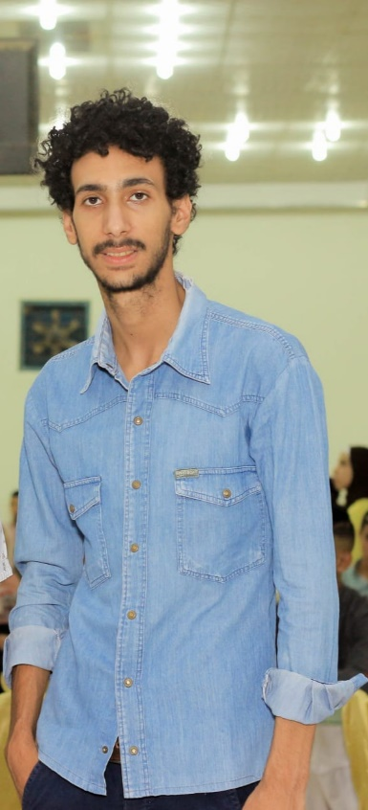+++++++++++++

Eslam Mostafa

Vice head marketing

<https://www.linkedin.com/in/eslam-mostafa-3a3a05215>

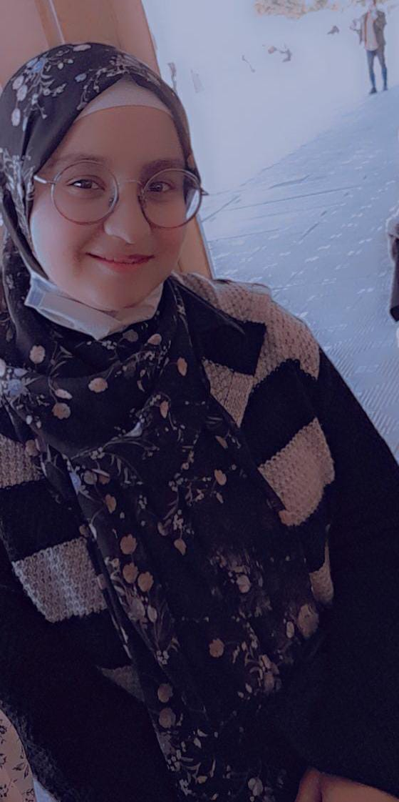**OC**

Asmaa Hamdy Abd Allah

Head OC

<https://www.linkedin.com/in/asma-hamdi-236785223>

Abdalla Mostafa Mohamed

Vice OC

<https://www.linkedin.com/in/abdallh-mostafa-508b42227>

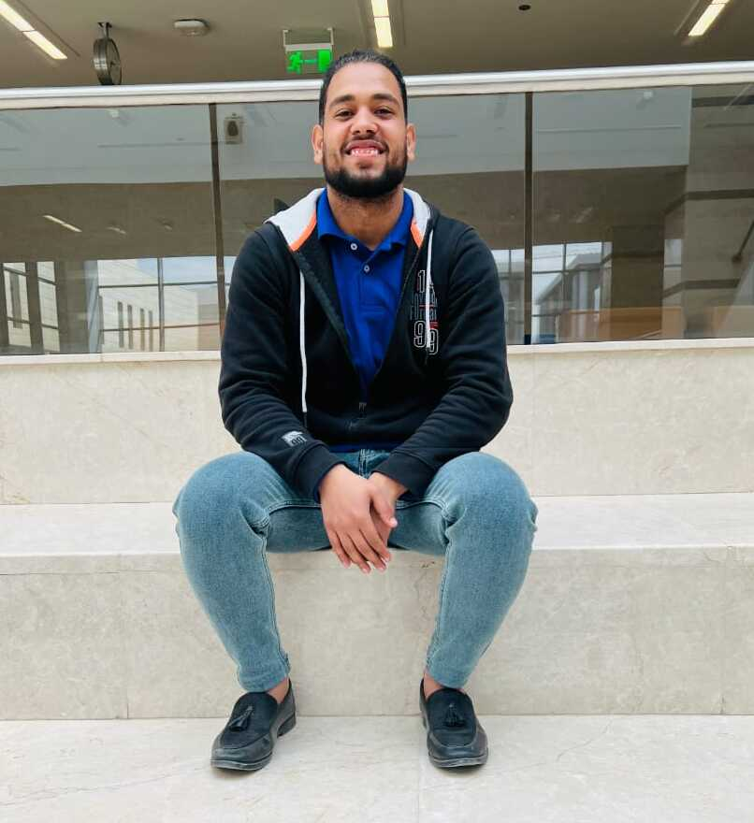

**Business**

Mohamed Ahmed

Head business

<https://www.linkedin.com/in/mohamed-ahmed-rammadan-60154919a>

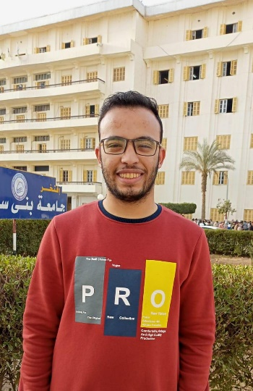

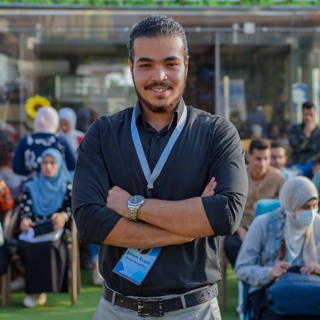**media**

Eslam Ezzat

Head Media

<https://www.linkedin.com/in/esllamofficial/>

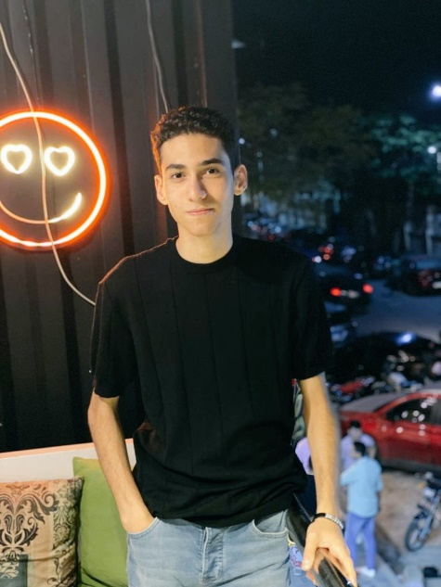Mohamed Ramadan

Vice Graphic

<https://www.linkedin.com/public-profile/settings>

Abdelrhman Essam

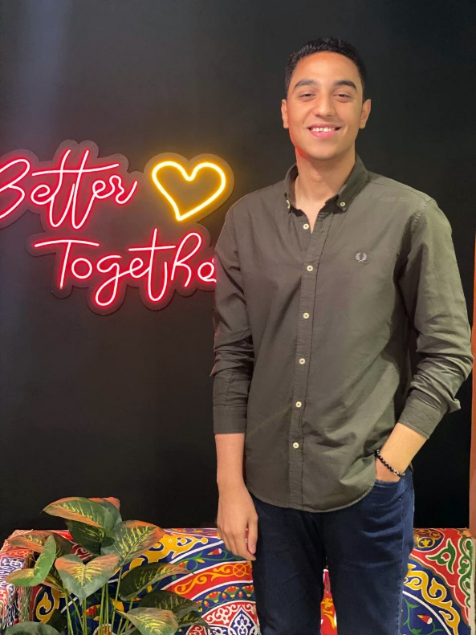Vice-Graphic

<https://www.linkedin.com/in/abdelrhmanessam74>

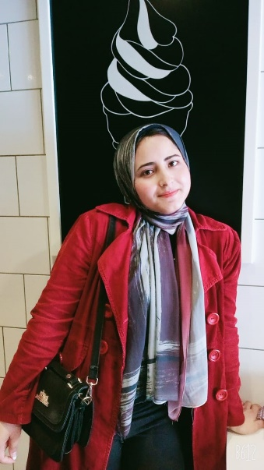**PR**

Youssra Ashraf Sedawi

Head pr

<https://www.linkedin.com/in/youssra-ashraf-140933236>

Omar lotfy

President

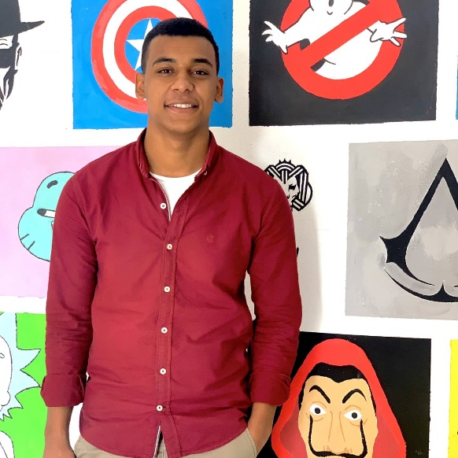<https://www.linkedin.com/in/omar-lotfy-001a131b7>

000

**Vice president**

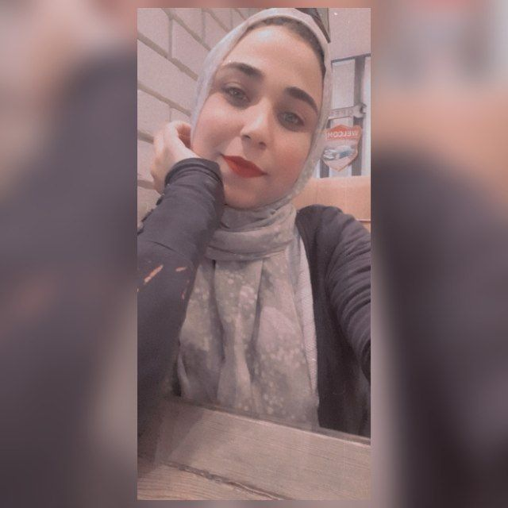Asmaa Samy

Vice president

<https://www.linkedin.com/in/asmaa-samy-506a27203>

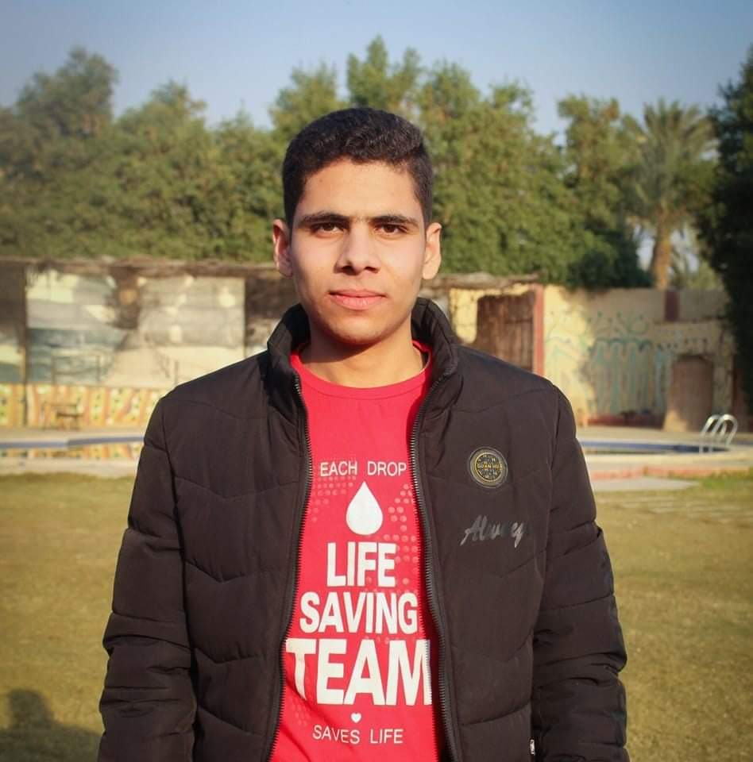**HR**

Mohamed Shaaban

Head HR

<https://linkedin.com/in/m22shaaban>